Sung Chi

007624253

CS 151

**Assignment 4 report**

1. **MVC Pattern**

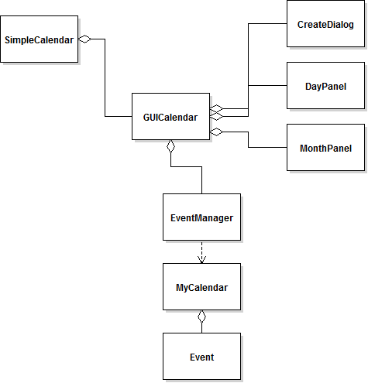

Above class diagram describes my SimpleCalendar program. In my program , MVC pattern is mainly used. EventManager contains all the data so it plays a Model role and DayPanel, Create Dialog and MonthPanel displays updated information that is stored in the model. So those 3 classes play Viewer role. Finally GUICalendar controls interactions between EventManager and the 3 viewer classes by holding the model and constantly updating the view.

1. **Screen Shot**

Screen 1: After starting the application (initial screen)

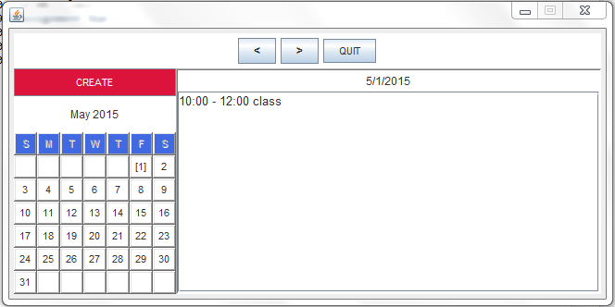

Screen 2: After clicking on the previous button on Screen 1

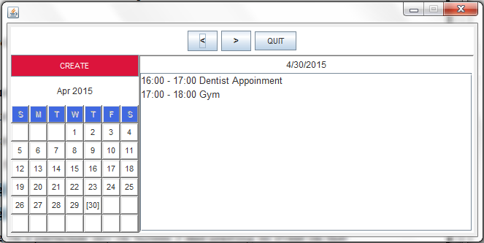

Screen 3: After clicking on the next button 20 times from Screen 2

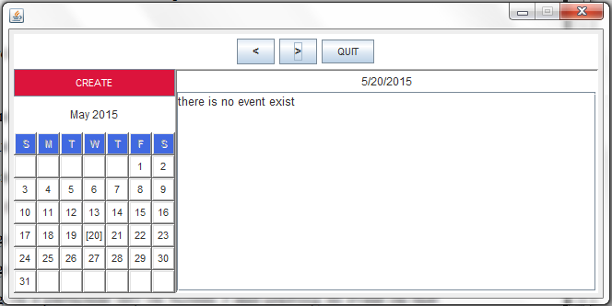

Screen 4: After clicking on a particular day on Screen 3 and creating an event on that day.

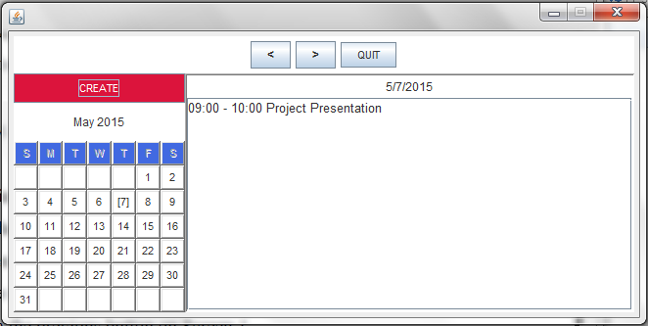

Screen 5: After clicking on the same day you choose in the previous step and creating an event with a time conflict.

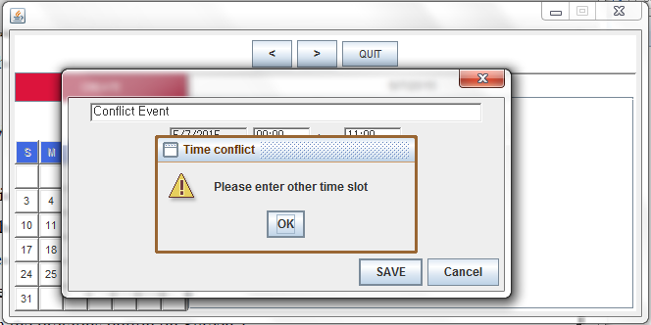

Screen 6: After entering an event on the same day you choose in the previous step and creating an event without a time conflict.

